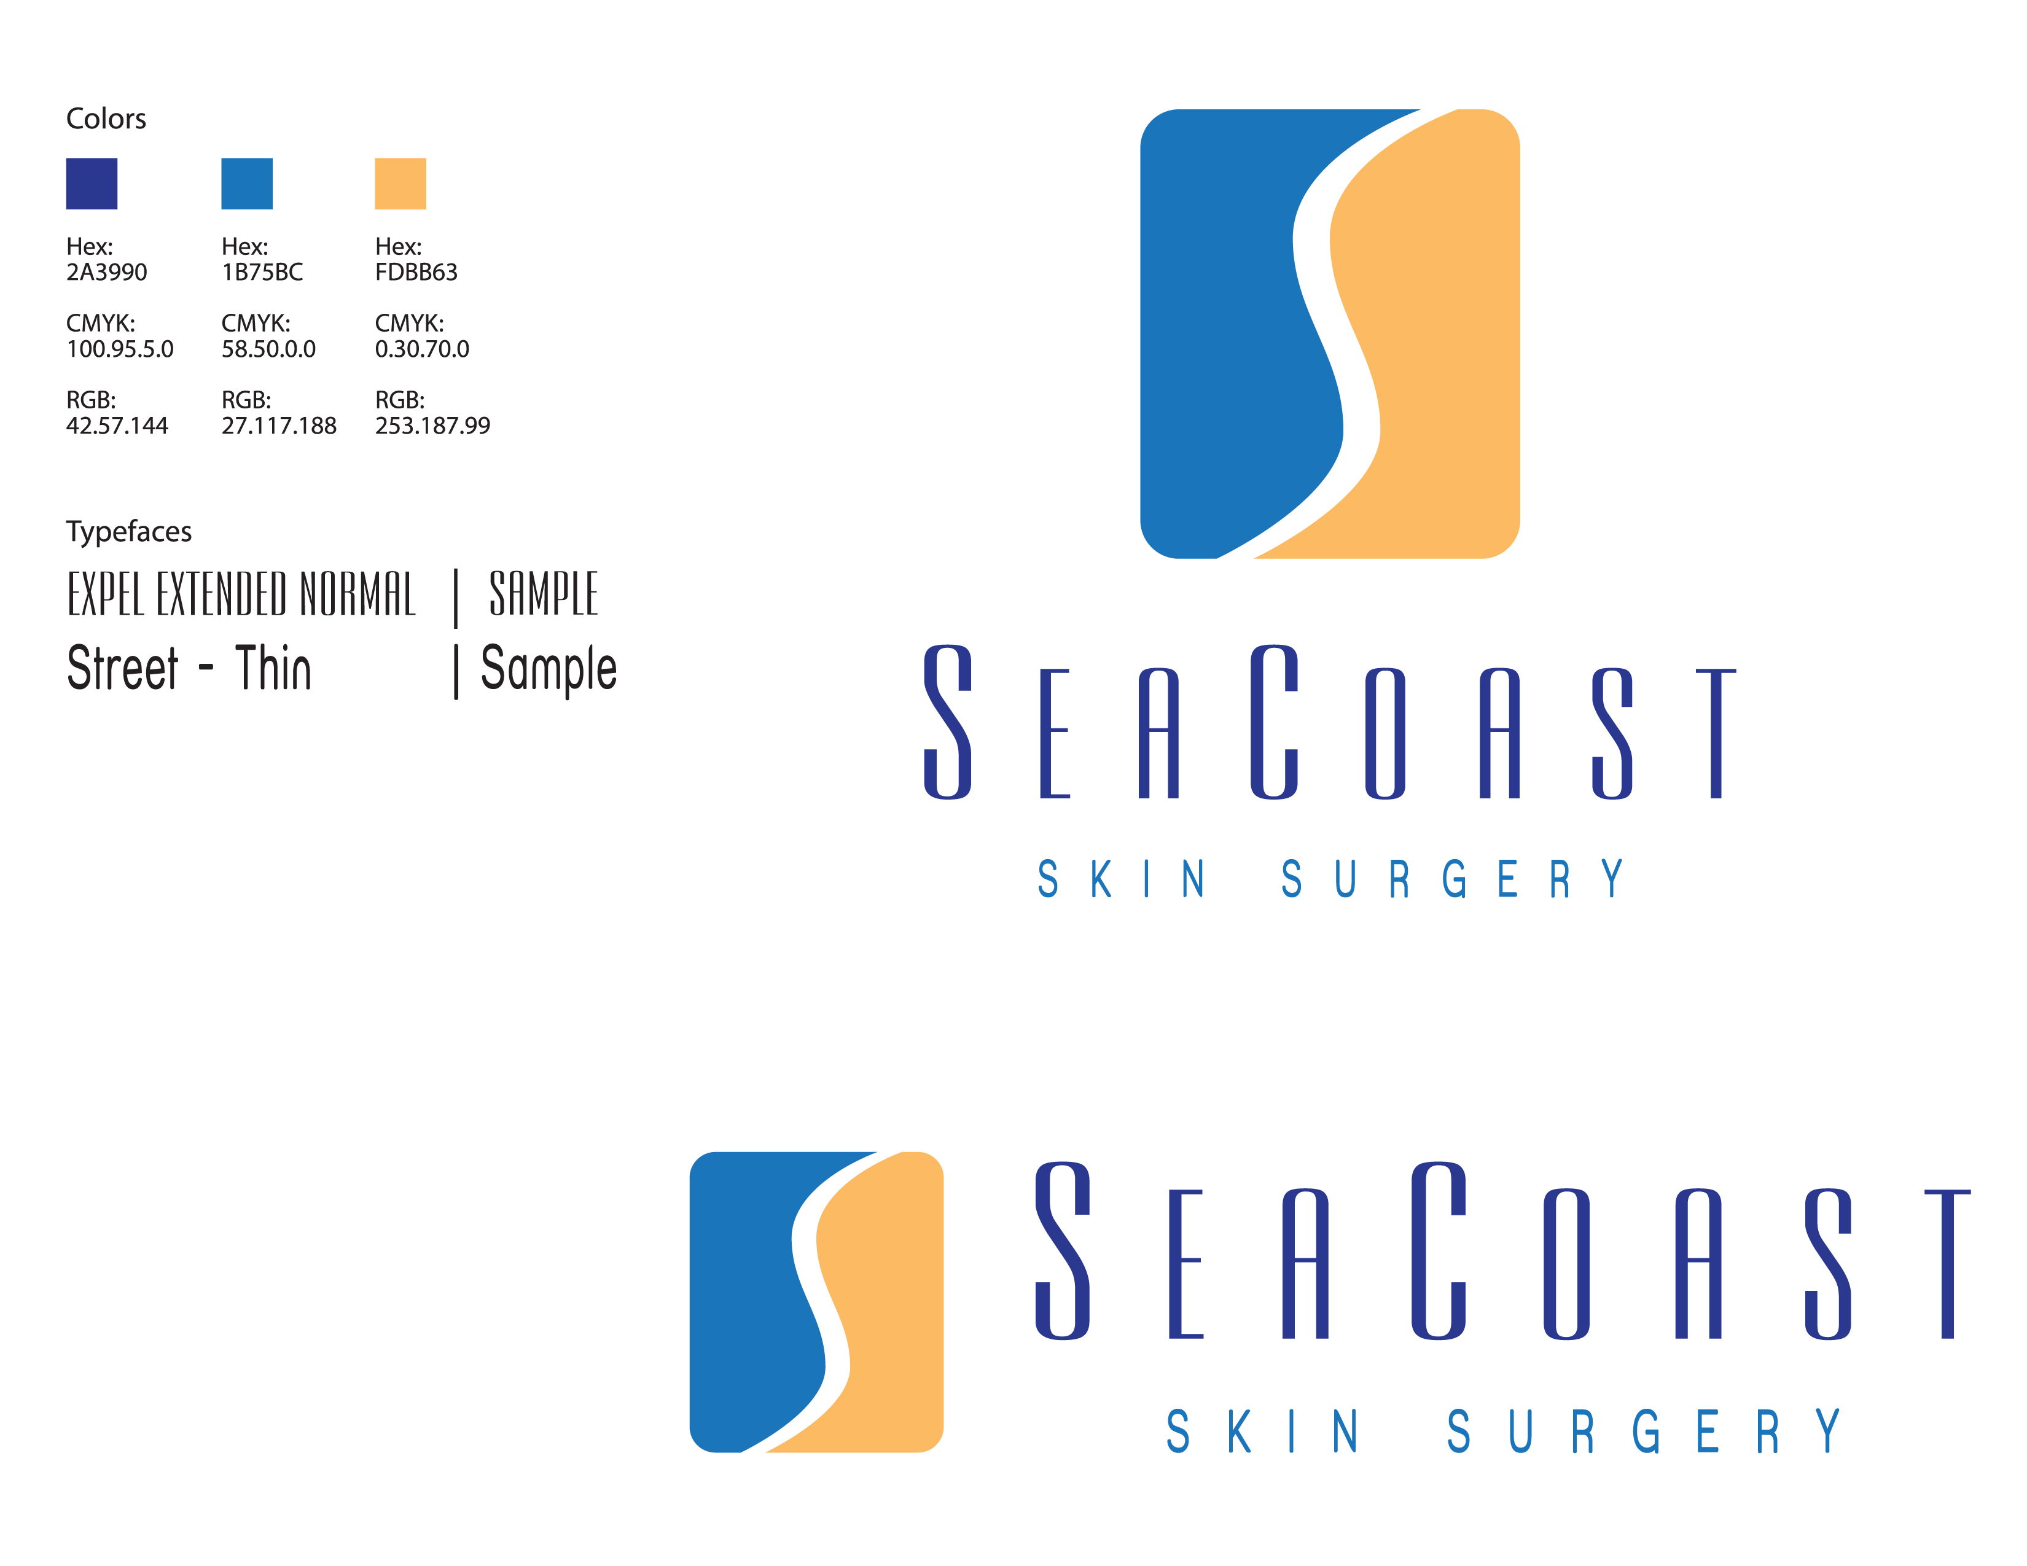

Phone: 910-256-2100
Fax: 910-256-7999
SeaCoast Skin Surgery 11/3/2008
SeaCoast Skin Surgery 11/3/2008
SeaCoast Skin Surgery 11/3/2008
After Suture Removal Instructions

INSTRUCTIONS FOR CARE OF SURGICAL SITE AFTER SUTURE REMOVAL

- If steri-strips have been applied:
- Allow them to fall off on their own. DO NOT PULL STERISTRIPS OFF!
- DO NOT apply Vaseline or sunscreen until steri-strips have fallen off.
- The ends of the strips may be trimmed off as they loosen and lift.
- Steri-strips should remain on the skin from several days to 2 weeks. They may be gently removed after 2 weeks.

- If skin adhesive has been applied:
- DO NOT swim in chlorinated pools/hot tubs. Chlorine dissolves the skin adhesive.
- DO NOT apply anything to the site such as ointments, lotions, creams, or make up.
- If the adhesive begins to peel DO NOT pull it off or pick at it. Please allow it to fall off naturally. This can take up to 2 weeks.

3. Apply sunscreen daily once the area is completely healed to prevent darkening of the scar line.

ADDITIONAL INSTRUCTIONS:
- Pimple-like bump(s) may appear along suture line. This may indicate that your body is “spitting” out internal sutures rather than dissolving them. No intervention is needed. It may take internal sutures several months to dissolve.

- Suture line will remain pink for several weeks to several months. Firmness of the scar is common. If your scar begins to heal abnormally, please call our office.

- Mild swelling is common, but will resolve.

4. If you experience fever, excessive drainage, separation of the skin edges, or bleeding at the site then please call us during normal business hours.

Further questions can be addressed through our office at 910-256-2100. Our normal business hours are Monday, Tuesday and Thursday, 7:30am – 5:00pm and 7:30am – 1:00pm on Wednesday and Friday
SeaCoast Skin Surgery 11/3/2008

